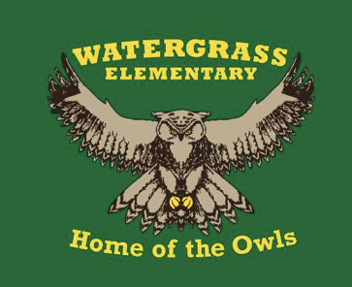

Success Plan at a Glance 2021-22
High Impact Instruction
Teachers ensure that student learning experiences match the rigor of the standards.
Focus on implementation of Core Action 3 on the IPG tool.

PLCs will analyze the B.E.S.T. standards for ELA to ensure assignments and tasks are aligned to the grade level expectation.

Implement new curriculum resources in ELA in grades K-5.

Each PLC will identify math essential standards for their grade level in order to drive interventions.

Data Driven Decisions
School uses a systemic approach to monitoring proficiency and growth over time for all students matched to the rigor of the standards.
Revisit school-wide Resource Map in order to implement consistent, equitable, and targeted Tier 2 and Tier 3 interventions to students who are not yet meeting grade level expectations in Reading and Math.

PLCs will have a common monitoring system to assess implementation and results of Tier 2 and Tier 3 interventions in Reading and Math through PLCs and quarterly data chats.

PLCs will monitor students’ progress towards mastery of the math essential standards on a monthly basis/every 6 weeks.

Collaborative Culture
School sustains a culture of collective responsibility by increasing student, staff, and community engagement.
Each PLC will create common structures for their classrooms that align to the Social Emotional Learning standards in order to create a compassionate learning environment.

The PBIS Committee will create criteria for student selection and support the implementation of structures for Tier 2 Social Emotional Learning.

The PBIS Committee and Administration will recognize staff and students for following school-wide expectations.

Develop and continue opportunities for staff connection.

Staff will use their individual strengths to collaborate as we work towards accomplishing our success plan goals together.

Offer family engagement opportunities related to High Impact Instruction, specifically the B.E.S.T. Standards and new curriculum resources.

