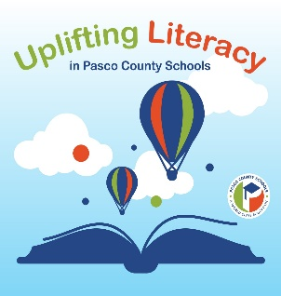
Watergrass Elementary
 | A Vision for Excellent Instruction  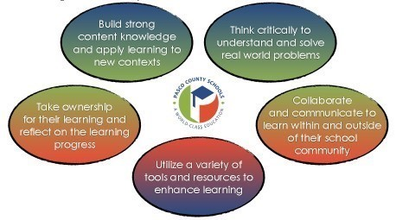  In Pasco County Schools, we are committed to providing a world class education and ensuring each of our students is prepared for college, career, and life when they cross the stage. A core element for delivering on that promise is equipping every child with the ability to read -- and read well. Learning to read is an essential skill to not only find success in school and to thrive in society, but to also experience the joy that reading brings to life. We have a common vision for instructional excellence and want every child to be a strong reader who can use their skills to build knowledge, engage confidently in the world around them and positively contribute to their community.  Research is clear on how children learn to read, how to make sure every student learns to read, and what to do when a child encounters difficulty in learning to read. The research that we are learning about, and implementing is called the Science of Reading. | The science of reading is telling us that while reading is more challenging for some students than others, with evidence-based reading instruction, nearly every child can become proficient by the end of 3rd grade. We can realistically set 95% proficiency as our goal in three years. The NEW Florida Benchmarks for Excellence in Student Thinking (B.E.S.T) Standards in English Language Arts are rooted in the science of reading and prioritize this learning for each of our students, especially in the early grades. These Benchmarks along with a clear vision for instructional excellence in literacy, strong instruction, high quality curricular resources and meaningful family partnerships are the guiding forces that will allow us to uplift literacy in Pasco County Schools.  Instruction in Foundational Skills, Language, and Morphology Building Knowledge and Vocabulary Through Texts  Reading Critically to Deepen Understanding of Complex Text Writing and Speaking to Develop Ideas and Communicate Text-Based Knowledge  Instructional Excellence in Literacy  If your family has been a part of Pasco County Schools for some time, you'll notice some changes in how we teach reading; if we’re new, jump on board, it's going to be a fantastic journey! It's an exciting time to be in education as we align our instruction with the Science of Reading!

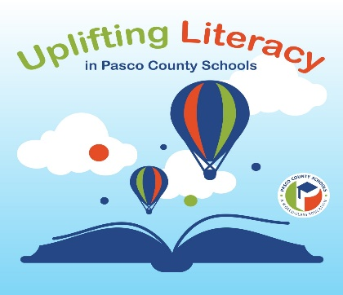
Listed below are some points of research that we will be addressing as we embark on a new school year in our Elementary Schools.

Phonemic awareness. This is the ability to hear the individual sounds in word, identify those sounds, and manipulate them orally. While this skill will be emphasized in grades K-1, we will make sure all students have this necessary foundation. Students in grades 2-5 may need to practice these skills until they have firmed up this foundation of reading. Don't be surprised if your student is working on phonemic awareness! This is an area that the research has indicated is tremendously important!
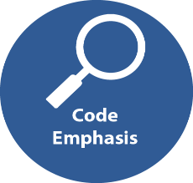
Code Emphasis in Primary Grades. This means that grades K 2 especially will focus on acquiring the skills to crack the code of our alphabet to the speech sounds in English. (There are 44 speech sounds in English and 150 ways to read and spell them!) Kids must first learn to decode/sound-out words before they can understand the meaning of text, therefore, we will emphasize instruction in 'cracking the code' in grades K-2.
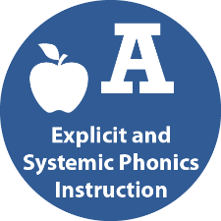
Explicit and systematic phonics instruction. We will have an order or continuum of phonics skills, progressing from simple to complex, that will be instructed directly throughout the early grades. Students will progress through the continuum as they master skills. In the intermediate grades (3-5), word study will continue with more instruction in grammar and morphology (learning about word parts such as Greek and Latin roots).
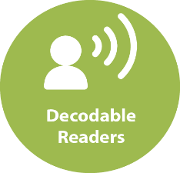
Decodable Readers. Our early readers will be working with decodable readers. These are books or passages that only include words that the students can 'decode' (sound-out) according to the skills they have been taught thus far. Our kids need practice with the phonics skills they are learning, and these books and passages provide that practice. So be aware that at times, your primary students may be bringing home a sheet of paper with a passage for practice rather than a book.

Leveled Readers. Your child will work with a variety of texts, including articles, stories, poems, images, etc. Some text may address specific phonics needs, some may be grade level text to build knowledge that is pertinent to their grade level, some may be interest-based, some will be at a determined level for fluency practice, but they will not be confined to a certain 'level’ and our classroom and school libraries will be open for students to browse freely based on interests and knowledge students are actively building. Kindergarten and first grade students will not bring home books with patterned sentences that are easily memorized; decodable readers and passages will be used instead.
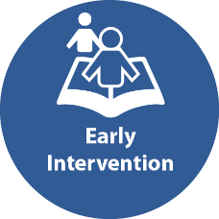
Early intervention. If we see any signs that your child may be struggling with the foundational skills of reading, we will immediately implement interventions and monitor their progress. The best solution to the problem of reading failure is early identification and intervention.

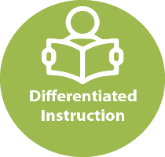
Differentiated Instruction. We have a very effective structure in place allowing students time to practice their reading independently while teachers work with small groups of students in a 15–20-minute lesson but we will be changing what we call it. IRLA time will now be referred to as Differentiated Instruction with students working in small groups, pairs and independently practicing their reading skills and building knowledge in their areas of interest. Although we are still guiding students through reading lessons, we are choosing to distance ourselves from the IRLA time because that term is connected closely with the practice of leveling students which research and evidence have proven not to be the best method for reading instruction. Students will be grouped for a variety of purposes including, but not limited to, needs in phonemic awareness, phonics, fluency, writing projects or knowledge building/interest, but they will not be grouped based on a reading level.

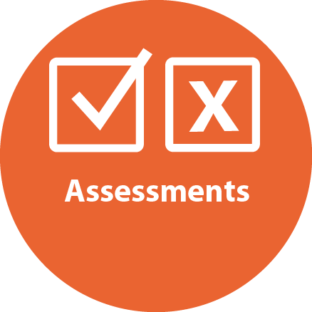
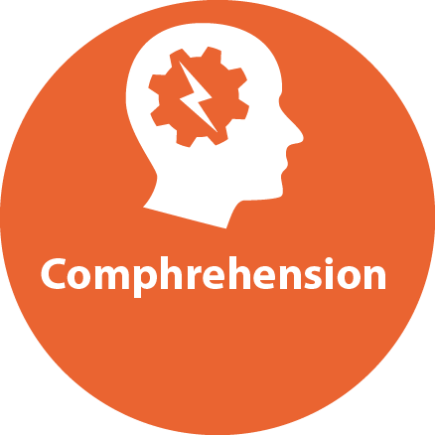
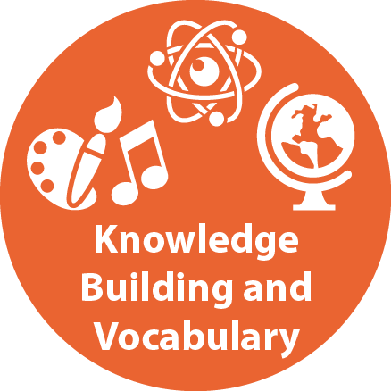

Knowledge Building and Vocabulary. Research has indicated that reading comprehension is closely connected to the background knowledge we have on a topic we're reading about and by understanding the vocabulary contained in the text. Pasco County Schools is adopting knowledge-building language arts curriculum called IntoReading. Our students will have the opportunity to build a broad knowledge base of history/social studies, science, and the arts. Kids will have access to complex text, learn how to access those texts, and in the process, gain more complex vocabulary. The research tells us that building knowledge and vocabulary contributes significantly to their reading comprehension and should be taught beginning in the earliest grades.

Comprehension. The goal of all reading instruction is for students to understand what they read. The model of The Simple View of Reading demonstrates that reading comprehension occurs only when students have both Decoding/Word Recognition Skills and Language Comprehension skills. Children need the essential skills to get the words off the page as well as knowledge, vocabulary, and a good understanding of how our language works in order to comprehend what they read. We must provide instruction that will help students achieve these goals.

Assessments. Your child will not be assigned an IRLA color level as in the past. Students will be assessed on the Oral Reading Fluency rate for their grade level. These nationally normed one-minute assessments give us a good indication of how easy or difficult reading is for your child. From there, we will give diagnostic assessments in word reading and nonsense word reading to find out which areas in the continuum of phonics skills they need help with. They will also be assessed on Phonemic Awareness so we can make sure they have those crucial foundational skills. As students become proficient word readers, comprehension is a natural outcome. Comprehension will also be checked regularly and if your child shows a weakness in any area, they will be progress monitored and given interventions to help them become stronger in those areas.

Three-cueing system. This is the practice of teaching kids to identify words by using strategies other than decoding. In the three-cueing system, students are taught that they can identify a word by deciding if it makes sense, if it would structurally/grammatically 'fit' in a sentence, or if it looks right rather than closely examining the phonics patterns in the word and sounding it out. This is a practice that the research has indicated that we must abandon. Your child will not be taught to check pictures to identify words or make guesses based on the first letter they see. We want our students to look at every letter in the words, apply phonics knowledge, and sound words out!

We know a great deal about how the brain develops as we learn to read and what instructional practices are most effective for all children. We are committed to using scientific research to ensure that we deliver on the promise of literacy for every Pasco County Schools student. Again, it's an exciting time to be in education and our partnerships with parents and families are essential for student success. We are grateful to be in this work together.
