Ms. Terra’s K-5 supply list

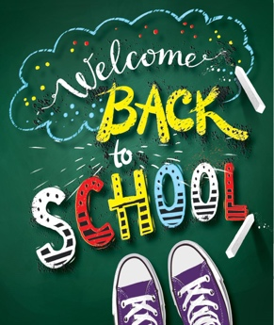
This Photo by Unknown Author is licensed under CC BY-NC

• 1 book bag
• 2 packs of baby wipes
• 2 packs of glue sticks (purple glue)
• 1 one- inch 3-ring binder with clear sleeve on outside front cover
• 1 box of sharpened #2 pencils
• 1 box of Crayola crayons
• 1 box of Crayola markers
• 1 plastic three-prong folder
• 1 box of snack size Ziploc bags
• 1 box gallon size Ziploc bags
• 1 pack of construction paper
• 1 pencil box (large enough to store markers, crayons, glue and scissors)
• 1 bottle of hand sanitizer
• 2 containers of disinfectant wipes
• 1 box of tissues
• magic erasers
• change of clothes

