MS. ASHLEY'S SUPPLY LIST
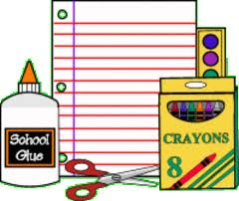

-Change of clothes, labeled with name
-Backpack (regular size, no wheels)
-Blanket for nap
-1 package dry erase markers
-1 box of baby wipes
-1 box of baggies (quart or gallon)
-2 boxes of Kleenex
-1 box of crayons
-1 box of markers
-2 glue sticks
-1 Crayola washable watercolors (8 color pack)

WISH LIST
-Playdoh
-Paper plates (large or small)
-Small disposable cups (~5oz)
-Paper Towels
-Snacks to share
-Additional supply list items
-Clorox or Lysol Wipes

